- Purpose
  - The purpose of this document is to describe the procedure for assembling the Lower Frame on the Genesys 20 with Traction Drive.
- Scope
  - This SOP applies to all equipment assembly team members. The process applies to the following machine ID’s:
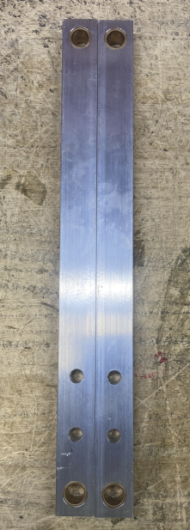
EP50287EQS0600BE1200 – Lower Frame (Disc/Orb)
- Responsibilities
  - The operations manager/supervisor is responsible for enforcing this SOP.
- Materials
  - The proper materials needed for this process are listed on the machine work order.
- Definitions

- Procedure
  - Take 2 head lift arms (E28863) and press a sleeve bearing (E28685) into the hole on each end.

  - Place a frame weldment (E28878) upside down on the table.

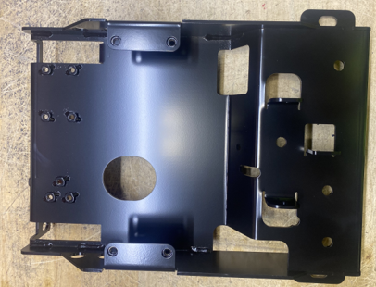
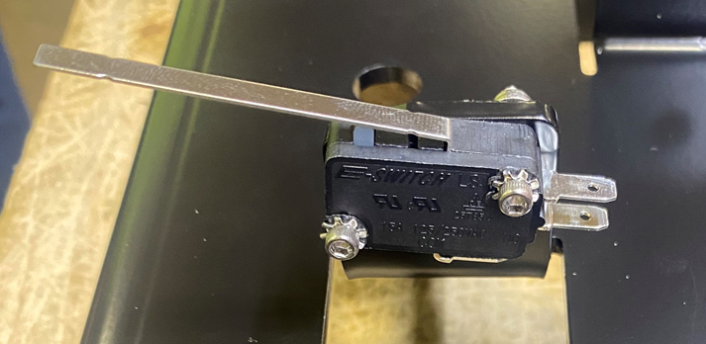
  - Attach a microswitch (E28952) to the location shown. Use 2 screws (E28769) with toothed washers (E28821) under the heads. Use a flat washer (E29368) with a nylock nut (E28770) on the other side. Ensure switch is pushed up completely before tightening.

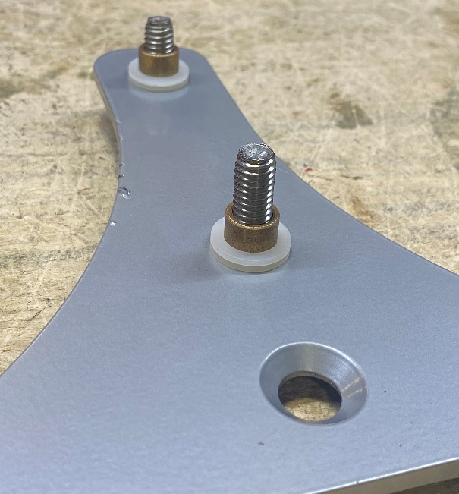
  - Take a squeegee swing plate (28880) ensure the countersink hole is facing up. Place a hex bolt (E29436) with a flat washer (E29438) though the bottom of the two holes of the swing plate. Then place 2 plastic washers (E28937) and a sleeve bearing (E28936) over each of the two bolts. Ensure both plastic washers are over the sleeve bearing and won’t get pinched.
Countersink Hole

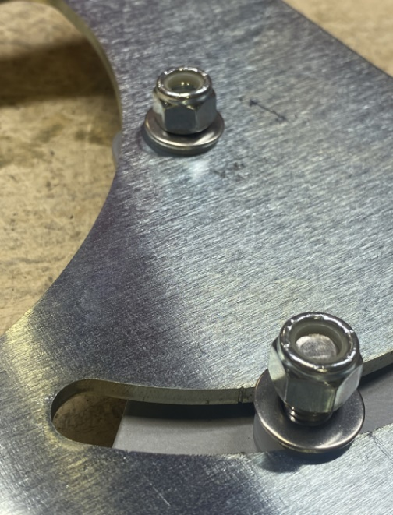
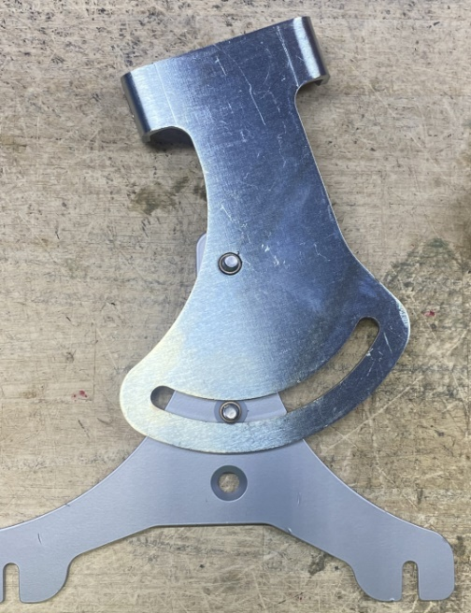
  - Place a squeegee lift bracket (E28879) over the swing plate. Line up the hole and fasten each bolt with a plastic washer (E28937), flat washer (E29438), and a nut (E11146) ensuring the brackets pivot freely. Note that the two plastic washers are now between the two plate and facilitate a smooth pivot.

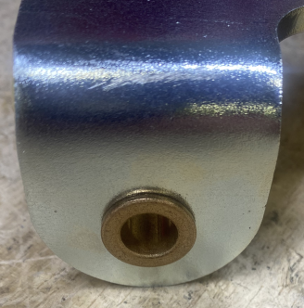
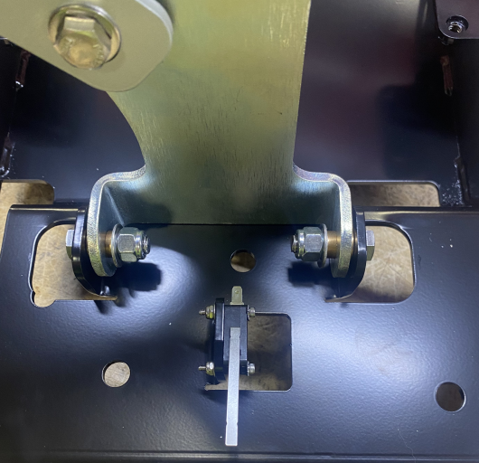
  - Put a flanged sleeve bearing (E28591) through each of the two holes in the pivot bracket. Put the pivot bracket into position on the frame and attach using 2 hex bolts (E29436), 2 washers (E29438) under the nuts, and 2 lock nuts (E11146). If there is extra space between the bracket and frame place a plastic washer (E83145) between the pivot bracket and the frame. Ensure the bracket actuates the switch properly when it pivots.
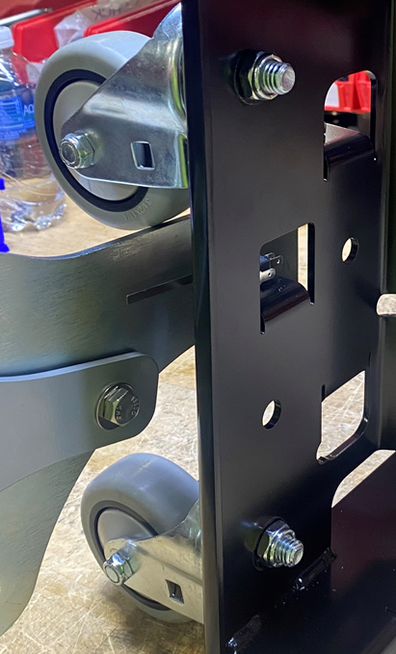
  - Attach the swivel casters (E29021) using 2 hex nut (E81088).

  - Take the 2 head lift arms and attach them to a lift arm brace (E28864) using a bolt (E10112) and washer (E28622). It is best to run a tap (5/16-18) through the tapped holes on the brace first. Four total bolts and washers will be used. When tightening the bolts, ensure the arms are laying on a flat surface. Try to keep them flat and parallel to each other while tightening. Insert a bushing (E28684) into the lift arm on the side with the brace.
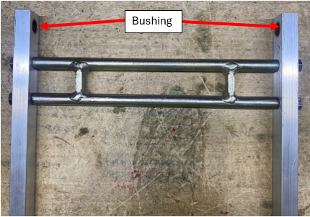
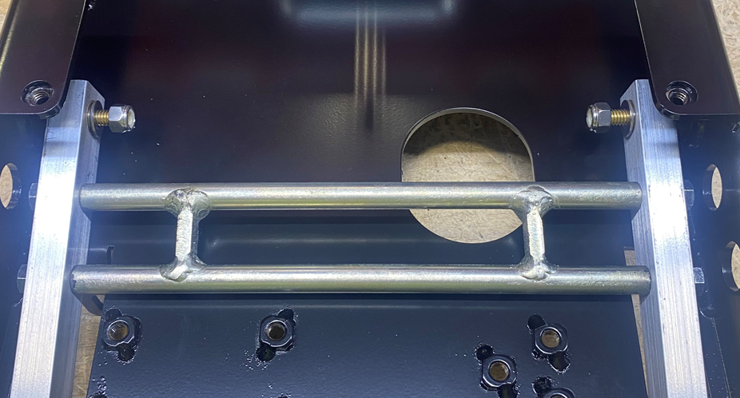
  - Attach each of the arms to the frame using a hex bolt (E28982), 2 flat washers each (E28622), and a nyloc nut (E28624) on each side. Tighten make sure the arms can pivot. Note: Washer must be outside and inside.

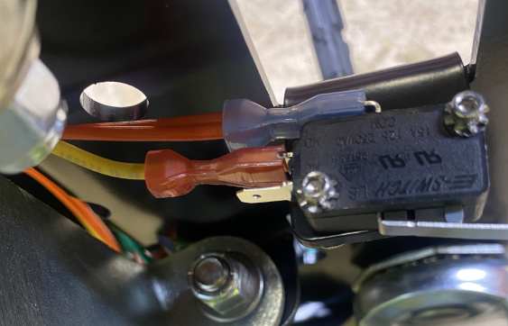
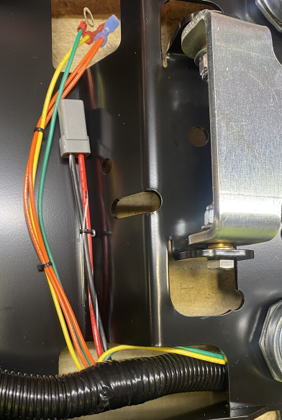
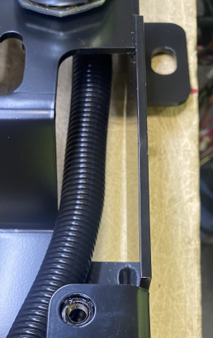
  - Take the wire harness (E28894 for a disk or E29001 for an orbital) and feed it through the frame. Ensure wires for pump, transaxle, etc are located properly. Attach the terminals to the squeegee lift microswitch. Note: double wire to higher prong and single to middle prong
Orange and yellow wire to switch
Green and Yellow to pump
Harness must go thru small opening

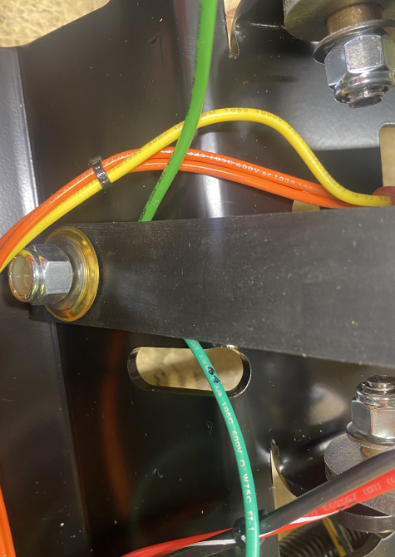
  - Take bolt (E29436) and place a flat washer (E29438) over it and thread through the underside of the frame. Hold bolt in place and add ground wires from transaxle and harness. Add static strap (E29459) before fastening on the washer (E29438) and nut (E11146)
Green ground from wire harness

Green ground from transaxle

  - Take a transaxle (E28876) and locate the electrical connector. The red and black wires need to be switched to match the main wire harness. Use a pair of needle nose pliers to remove the orange insert in the connector. Release the pin and pull it out the back. Repeat for the other pin and then reinstall them into the opposite slots. Use the pliers to reinstall the orange clip. Press on the clip until it snaps in place.

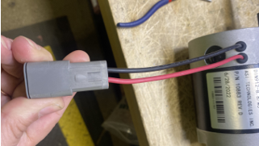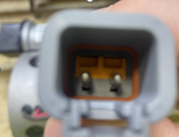

  - Lay the transaxle onto the frame in the orientation shown in the photo below. Connect the transaxle plug to the main harness and orient it in the way shown. This keeps it from dragging on the floor.

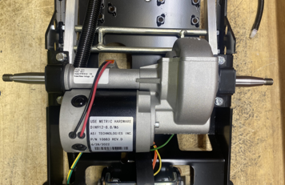

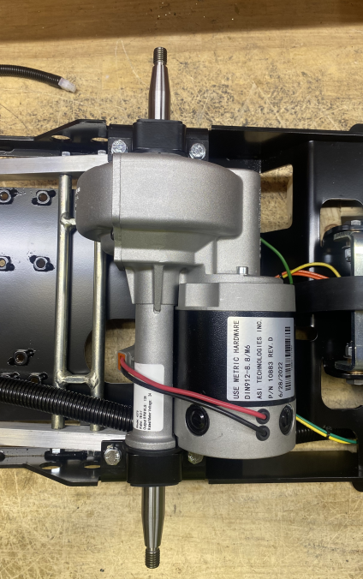
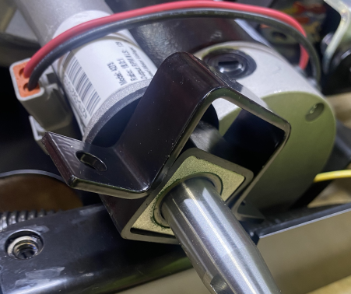
  - Attach the transaxle to the frame with brackets (E29400). Use a 4 hex bolts (E81089) and 4 lock washers (E81067) to do this.

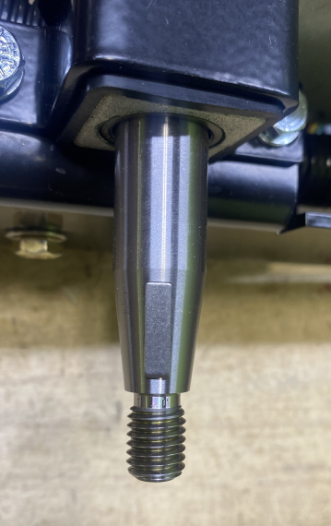
  - Place a woodruff key (E29439) into the slot on each side of the transaxle.

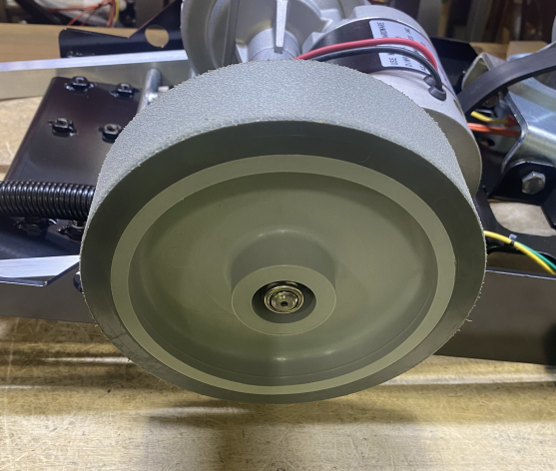
  - Attach drive wheels (E288882) onto both ends of the transaxle using washer (E93702) and nut (E86489). The wheel bores have a taper so they will only fit in one direction. Use the torque wrench to tighten them to 17 ft/lbs.
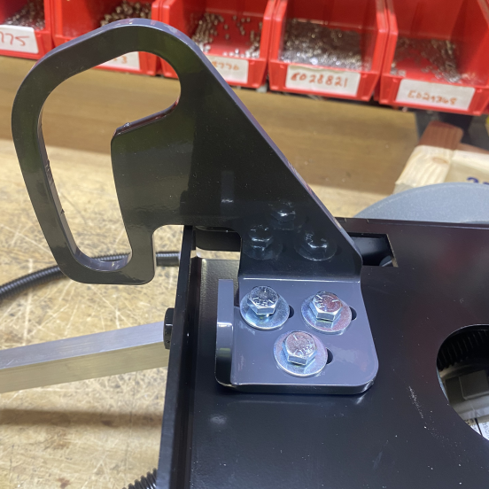
  - Turn frame over and place head lift guide (E28865) in appropriate location. Feed 3 bolts (E81089) and 3 washers (E81062) through the top and secure with nut (E28623). Do not tighten completely, leave loose.

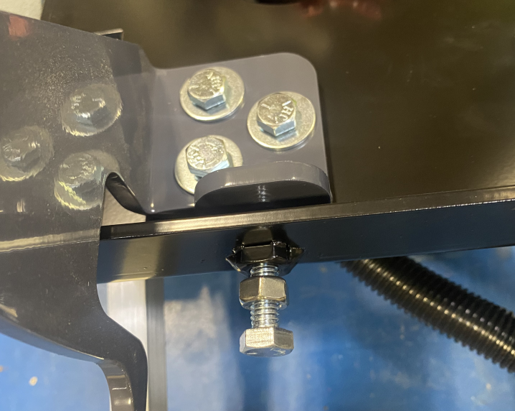
  - Thread nut (E12524) on to bolt (E10112) and screw into the front of the frame.
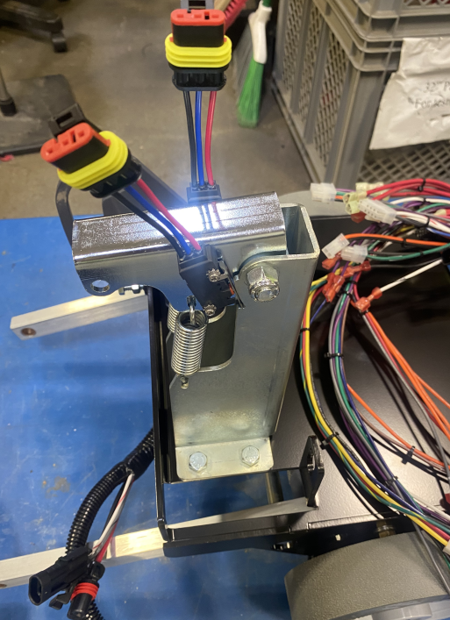
  - Place actuator tower on frame. Attach it with 4 bolts (E81089) and 4 washers (E28622). The frame includes welded on nuts on the bottom.

- References (optional section as needed)

- Training Guide

Functional Training Groups Requiring Training
Equipment Assembly Group

- SOP Change Control

Date of Change | Reason for Change
TBD | This is the first version of the S.O.P. hence there are no revisions to this document.
05/07/2025 | Updated and removed pad assist notes

Approvals

Submitter/Author Approval:__________________________________ Date:______________________

Management Approval:______________________________________ Date:______________________

QAU Approval:_____________________________________________ Date:______________________

